Cloud Computing

☁️ What is Cloud Computing?
# Source: AI Source: Provided by: [Data Path: Persons Table -> ID Column: 1, Name_En Column: Motasem Essam] -> From: [ChatGPT] on [1/26/2026]
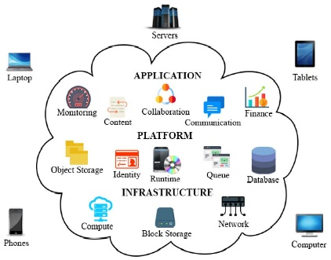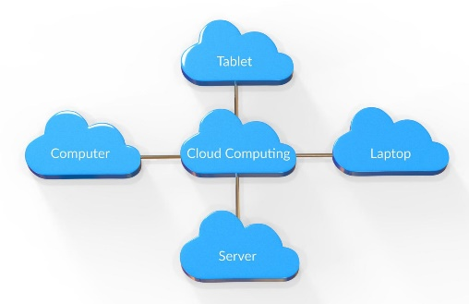
Cloud computing is the delivery of computing services—like servers, storage, databases, networking, software, and more—over the internet (“the cloud”) instead of using your own physical computer or local servers.

🧠 Simple Idea
# Source: AI Source: Provided by: [Data Path: Persons Table -> ID Column: 1, Name_En Column: Motasem Essam] -> From: [ChatGPT] on [1/26/2026]
Instead of:
- Saving files on your own laptop
- Running programs installed on your device
You:
- Store files online
- Access apps and services through the internet
👉 Example: Using Google Drive or Dropbox instead of saving files only on your computer.

🔑 Key Features
# Source: AI Source: Provided by: [Data Path: Persons Table -> ID Column: 1, Name_En Column: Motasem Essam] -> From: [ChatGPT] on [1/26/2026]
- On-demand access: Use resources whenever you need them
- Scalable: Increase or decrease usage easily
- Pay-as-you-go: Only pay for what you use
- Accessible anywhere: As long as you have internet

🧩 Types of Cloud Computing
# Source: AI Source: Provided by: [Data Path: Persons Table -> ID Column: 1, Name_En Column: Motasem Essam] -> From: [ChatGPT] on [1/26/2026]
1. Infrastructure as a Service (IaaS)
- Provides basic computing resources (servers, storage)
- Example: renting a virtual machine
2. Platform as a Service (PaaS)
- Provides tools for developers to build apps
- No need to manage hardware
3. Software as a Service (SaaS)
- Ready-to-use software via browser
- Example: email services, online office tools

🌍 Real-World Examples
# Source: AI Source: Provided by: [Data Path: Persons Table -> ID Column: 1, Name_En Column: Motasem Essam] -> From: [ChatGPT] on [1/26/2026]
- Streaming movies on Netflix
- Using Gmail
- Storing photos in iCloud
- Running websites on cloud servers

⚖️ Advantages
# Source: AI Source: Provided by: [Data Path: Persons Table -> ID Column: 1, Name_En Column: Motasem Essam] -> From: [ChatGPT] on [1/26/2026]
- Cost-effective (no need to buy hardware)
- Easy to scale
- Reliable backups
- Automatic updates

⚠️ Disadvantages
# Source: AI Source: Provided by: [Data Path: Persons Table -> ID Column: 1, Name_En Column: Motasem Essam] -> From: [ChatGPT] on [1/26/2026]
- Requires internet connection
- Data privacy concerns
- Possible downtime from providers

🧭 In One Sentence
# Source: AI Source: Provided by: [Data Path: Persons Table -> ID Column: 1, Name_En Column: Motasem Essam] -> From: [ChatGPT] on [1/26/2026]
Cloud computing = using powerful computers over the internet instead of your own device.

